PROJECT DOCUMENTATION
AI-FITTRACK-API

INTRODUCTION:
- Project title: AI-FitTrack-API
- Team id: SWTID-2026-2426
- Team leader: G.RAJESHWARI
Email-id: chitrag820@gmail.com

- Team members:
-S.JENIFER CHRISTIYA
Email id:jenischristiya2006@gmail.com

-R.MANISHA
Email id:manisharamamoorthy20@gmail.com

-D.PHEBE LOIS
Email id:phebelois76@gmail.com

-M.SARANYA
Email id:saranya934430@gmail.com

PROJECT OVERVIEW:

- AI-FitTrack-API is a backend application designed to manage fitness and workout-related information through APIs. The project provides a structured backend system for handling user information, workout activities, fitness data, and related operations.
- The application uses a RESTful API architecture and connects with a database to store and manage application data. It is developed using backend technologies such as Node.js, Express.js, and MongoDB.
- The project focuses on providing a reliable and organized API that can be connected with a frontend or mobile application for fitness tracking.

PURPOSE:
The main purpose of AI-FitTrack-API is to develop a backend API for a fitness tracking application.
The API helps to:

- Manage fitness and workout-related data.

- Store and retrieve user information.

- Perform CRUD operations on fitness records.

- Provide API endpoints for frontend applications.

- Store application data securely in MongoDB.

- Organize fitness-related information in a structured manner.
KEY FEATURES:
1. User Management
The system manages user-related information and provides the required API operations for handling user data. It allows the application to maintain user information in an organized manner.

2. Workout Management
The API manages workout-related information such as workout activities and fitness records. Users can add, view, update, and delete workout information through the available API endpoints.

3. RESTful API
The project provides RESTful APIs that allow the frontend or other client applications to communicate with the backend. Different HTTP methods such as GET, POST, PUT/PATCH, and DELETE are used according to the required operation.

4. MongoDB Database Integration
The application is connected with MongoDB to store and manage user and fitness-related information. The database provides a flexible and efficient way to handle application data.

5. API Validation and Error Handling
The system handles invalid requests, missing information, and server-side errors. Proper validation and error responses help maintain the reliability and stability of the application.

6.Sensitive configuration
Sensitive information such as database connection details and API keys are managed using environment variables. This helps prevent confidential information from being directly exposed in the source code.

ARCHITECTURE:
The AI-FitTrack-API follows a layered backend architecture. It separates different responsibilities of the application into different components.
Main Components
1. API / Routes Layer
This layer receives HTTP requests from the client and directs them to the appropriate controller.
2. Controller Layer
The controller handles the business logic of the application. It processes the request and generates the appropriate response.
3. Model Layer
The model defines the structure of the data and communicates with the MongoDB database.
4. Database Layer
MongoDB is used to store and manage the application data.
Basic Flow

Client → API Routes → Controllers → Models → MongoDB

The response follows the reverse path:

MongoDB → Models → Controllers → API → Client

COMPONENT DEFINITION:
- API Routes
- API routes define the endpoints through which the client communicates with the backend server.
- They handle different HTTP methods such as:
GET – Retrieve data
POST – Create new data
PUT/PATCH – Update existing data
DELETE – Delete data
- Controllers
- Controllers contain the main application logic.
They are responsible for:
- Processing API requests.
- Validating received information.
- Communicating with models.
- Performing required operations.
- Sending responses to the client.

- Models
- Models define the structure of data stored in the database.
They are used to:
- Define data fields.
- Validate data.
- Communicate with MongoDB.
- Perform database operations.

- Database
- The project uses MongoDB as the database.

MongoDB stores application information in a flexible document-based format. It allows the backend to efficiently create, retrieve, update, and delete fitness-related data.

STATE MANAGEMENT:
The backend manages application data through API requests and database operations.
When a client sends a request, the server processes the request and communicates with the database when required. The updated information is then returned to the client as an API response.
This approach keeps the application data synchronized between the client, backend, and database.

ROUTING :
Routing is used to define the different API endpoints of the application.

The routes determine:
- Which operation needs to be performed.
- Which controller should handle the request.
- What type of HTTP request is accepted.
- The application uses RESTful routing principles to provide a structured API.

SETUP INSTRUCTIONS:
Prerequisites
Before running the project, the following software is required:
- Node.js
- Npm
- MongoDB
- Visual Studio Code
- Postman or another API testing tool

Installation Steps
Step 1: Open the Project
Open the AI-FitTrack-API project folder in Visual Studio Code.
Step 2: Open Terminal
Open the terminal in Visual Studio Code.
Step 3: Install Dependencies
Run:
npm install
This installs all the required packages for the project.
Step 4: Configure Environment Variables
Create a .env file in the project directory and add the required configuration values such as:
PORT=5000
MONGODB_URI=your_mongodb_connection_string
Step 5: Start the Server
Run the appropriate start command configured in the project, for example:
npm start or npm run dev
When the server starts successfully, the terminal will display a message indicating that the server is running.

FOLDER STRUCTURE:
The project is organized into different folders to make the backend easy to understand and maintain.
A typical structure is:
AI-FitTrack-API/
│
├── controllers/
├── models/
├── routes/
├── middleware/
├── config/
├── .env
├── package.json
├── package-lock.json
└── server.js
Description
- controllers/
Contains the application logic for handling API requests.
- models/
Contains database models and data structures.
- routes/
Contains API endpoint definitions.
- middleware/
Contains middleware used for request processing, authentication, validation, or error handling.
- config/
Contains configuration-related files such as database connection settings.
- .env
Stores environment-specific values such as database connection strings and API keys.
- server.js
Acts as the main entry point of the backend application.

RUNNING THE APPLICATION:
To run the AI-FitTrack-API project:
1. Open the project in Visual Studio Code.

2. Open the terminal.

3. Install the dependencies using npm install.

4. Make sure MongoDB is running and the connection string is correctly configured.

5. Check the .env configuration.

6. Start the backend server.

7. Test the API endpoints using Postman.

8. Check the server response for successful API operations.
COMPONENT DOCUMENTATION:
The backend components work together to provide fitness tracking functionality.
- User Component
Handles user-related information and operations.
- Workout Component
Handles workout-related information such as workout activities and fitness records.
- API Component
Provides endpoints through which external applications can communicate with the backend.
- Database Component

Stores and retrieves application data using MongoDB.

- Authentication / Security Component
Handles protected application operations and keeps sensitive configuration information in environment variables.

API TESTING:
API testing is performed to verify that the backend endpoints work correctly.
Postman can be used to test the API.

The following operations can be tested:
- GET Request
Used to retrieve existing information from the server.
- POST Request
Used to send new information to the server.
- PUT/PATCH Request
Used to update existing information.
- DELETE Request
Used to remove information.
During testing, the following aspects are checked:
Correct HTTP status code.
Correct response format.
Correct database operation.
Proper error messages.
Validation of input

FUTURE INHANCEMENTS:
- AI-based personalized workout recommendations.

- Personalized fitness plans based on user information.

- Workout progress analysis.

- Fitness statistics and graphical reports.

- Integration with wearable fitness devices.

- Improved authentication and security.

- Nutrition and diet tracking.

- AI-based fitness suggestions.

SCREENSHOTS:
USER REGISTER:
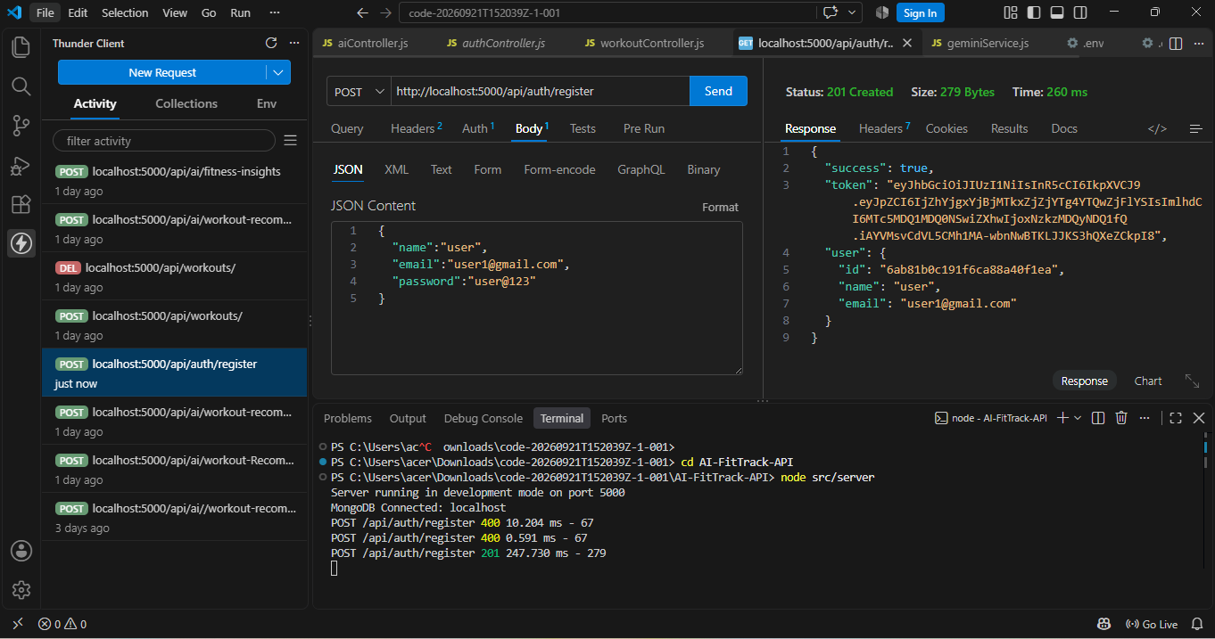

LOGIN USER:

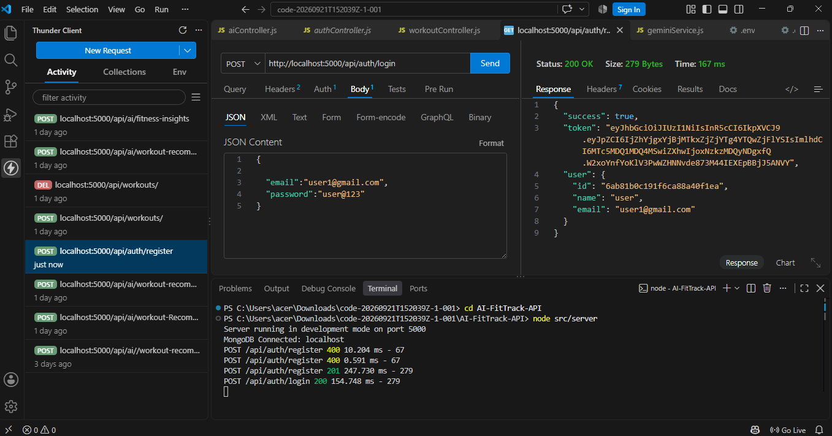

GET PROFILE:
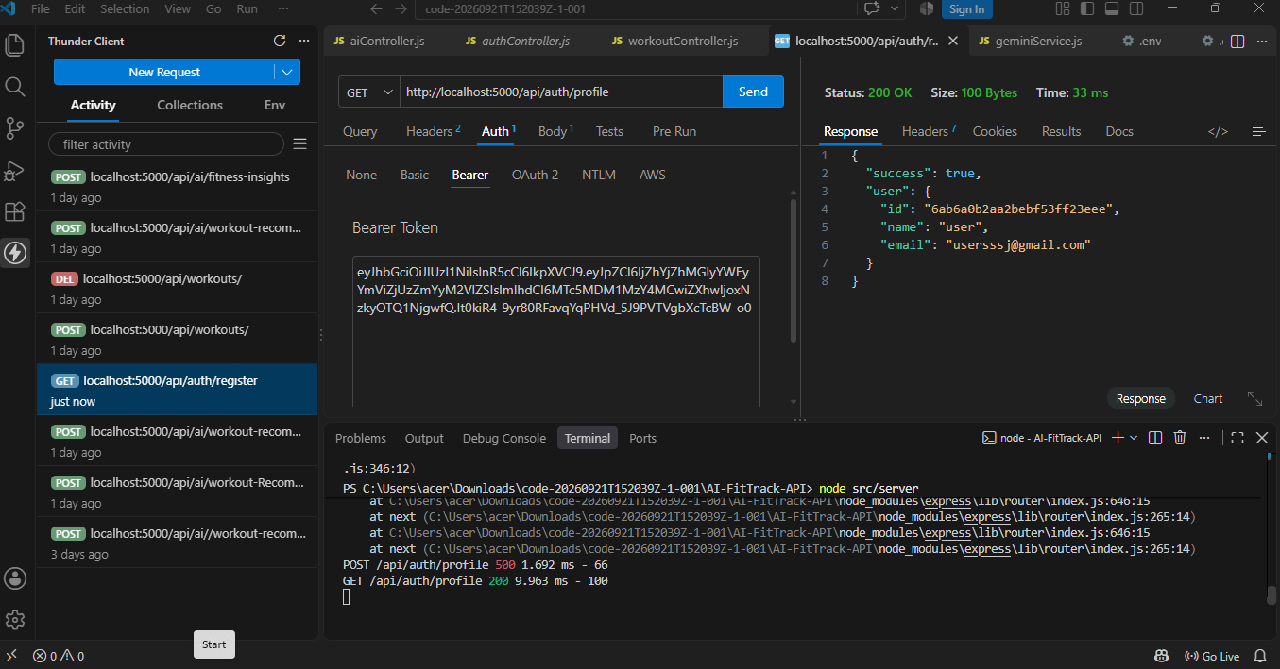

ADD WORKOUT:

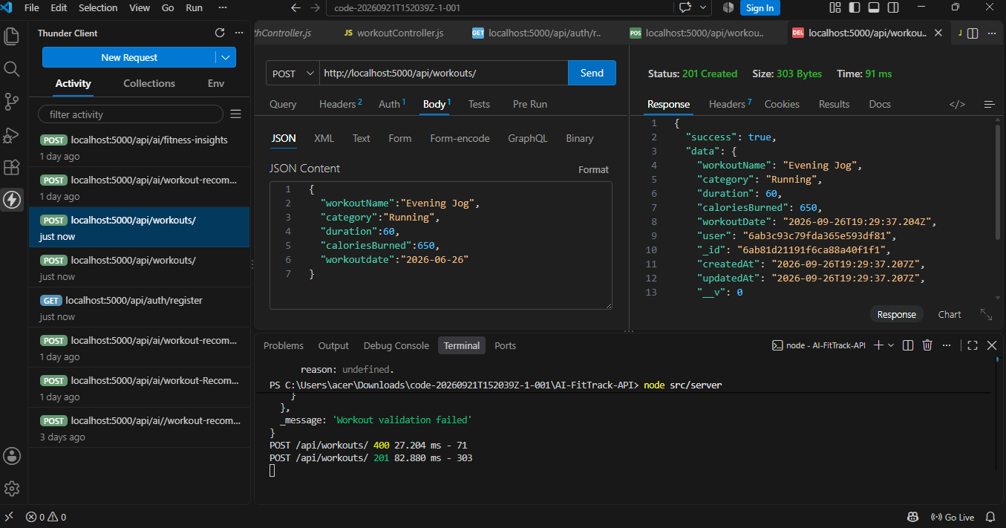
GET ALL WORKOUTS:

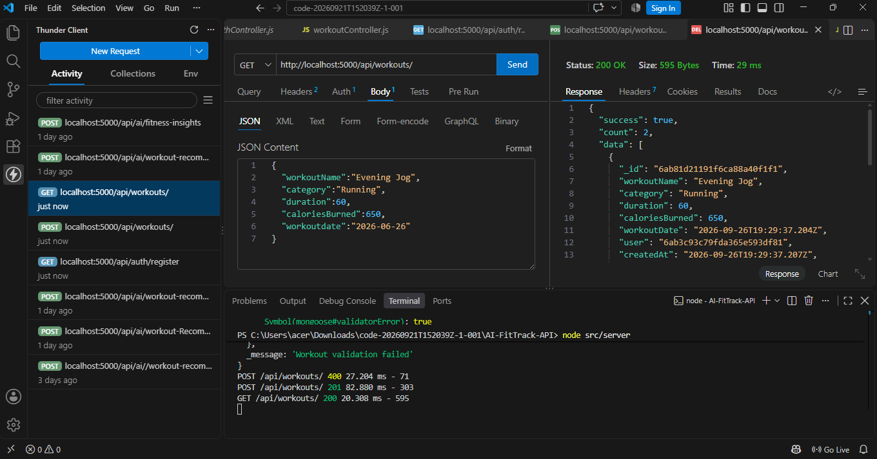

GET WORKOUT BY ID:

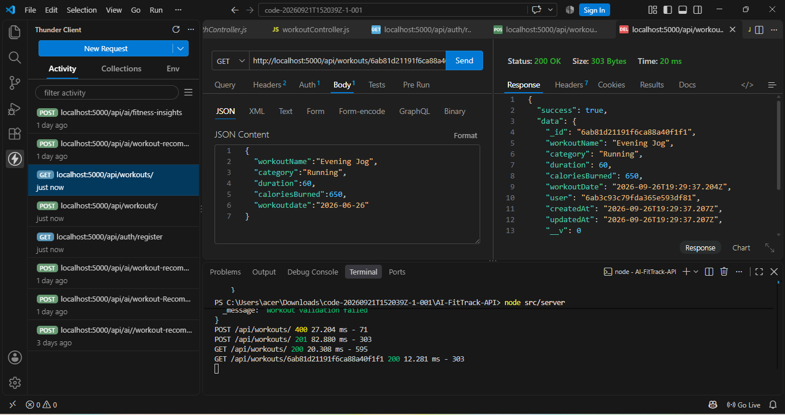
UPDATE WORKOUT:

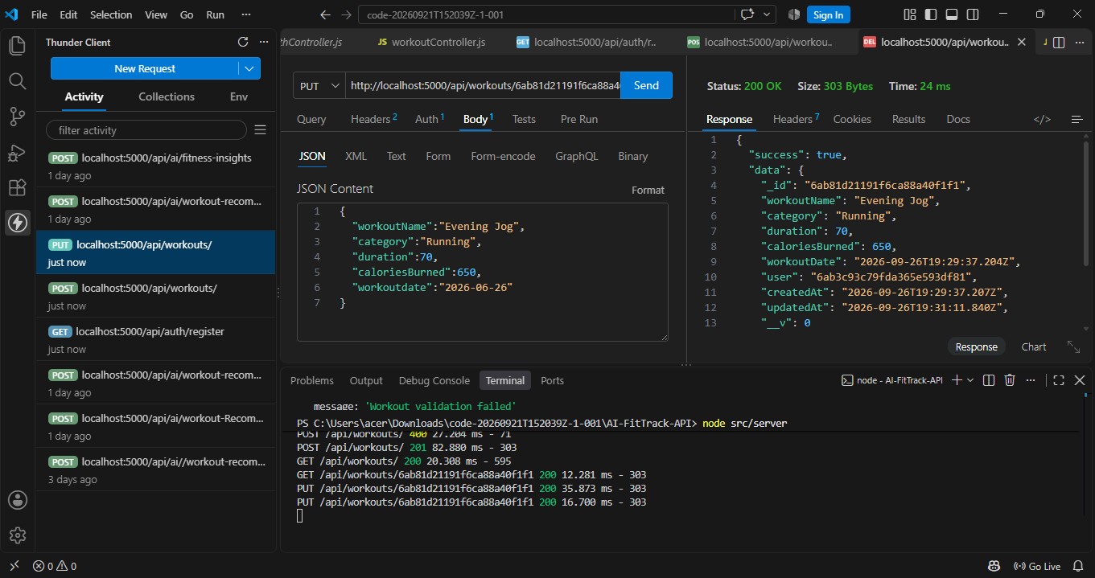

DELETE WORKOUT:

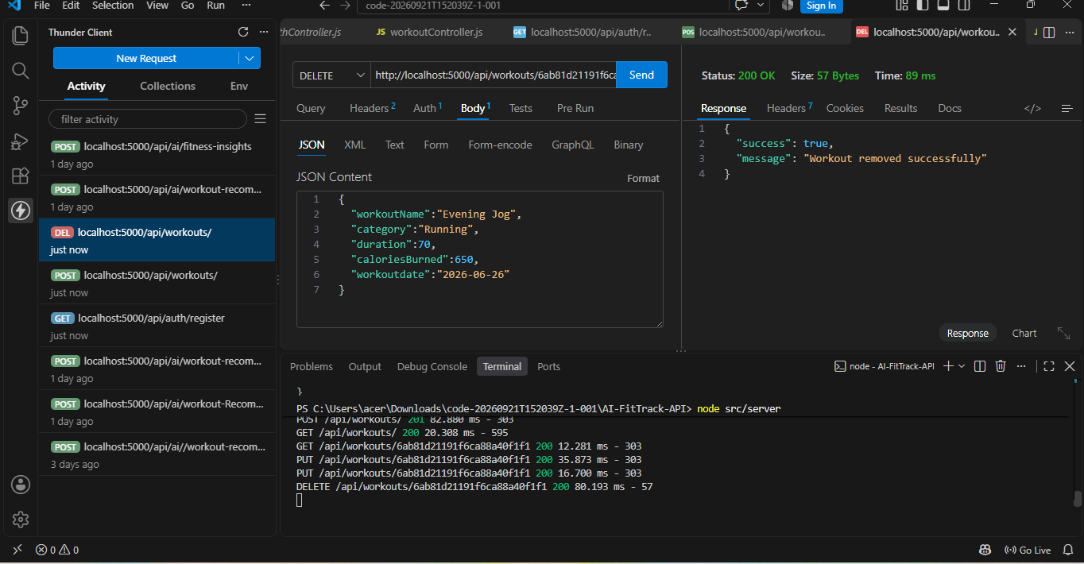
WORKOUT RECOMMENDATIONS:

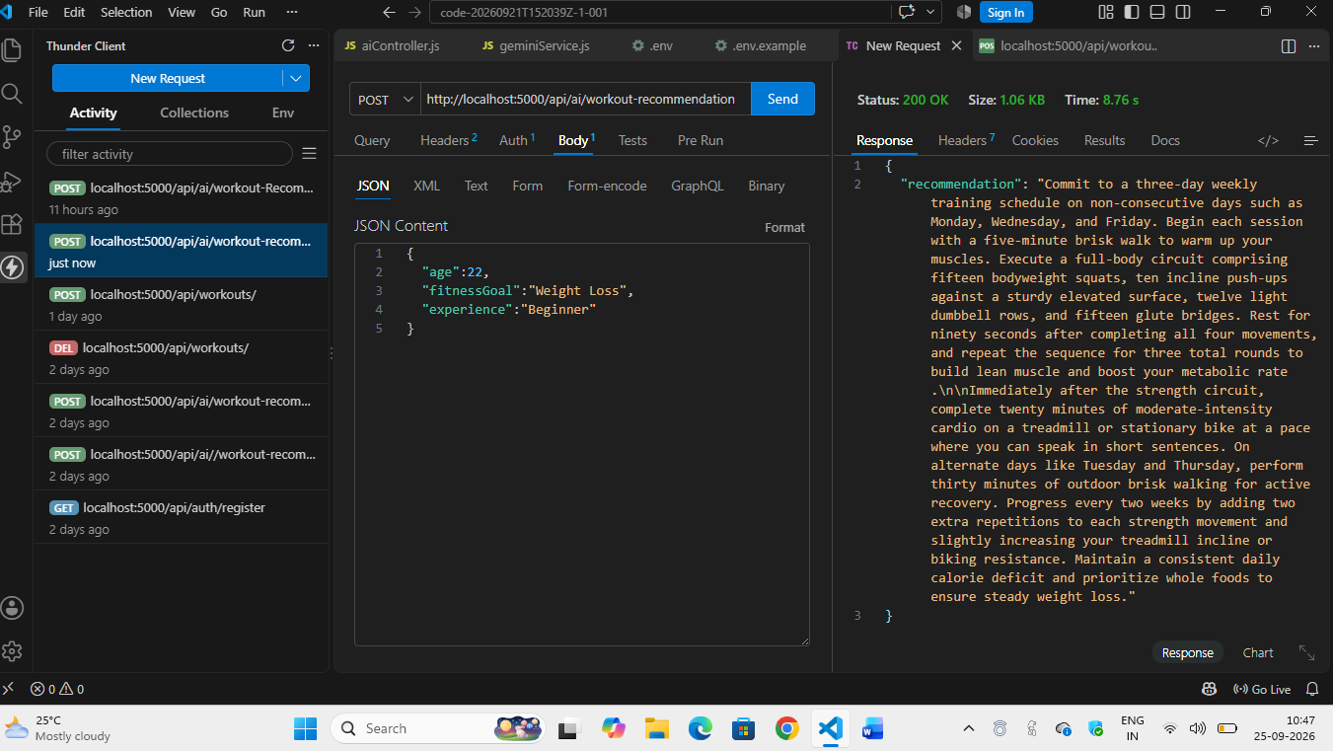

FITNESS INSIGHTS:

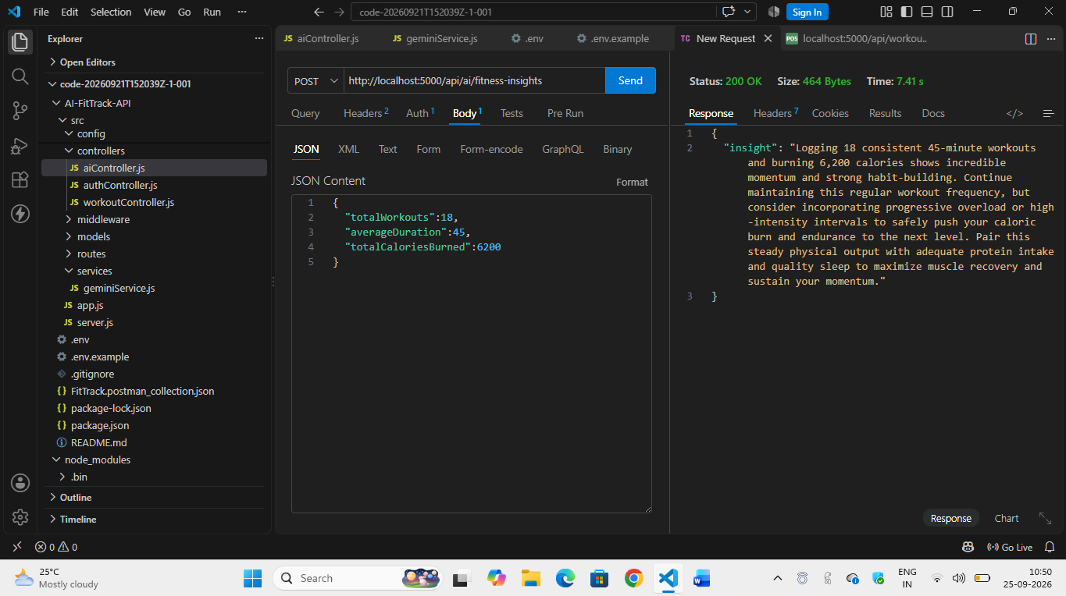
DEMO LINK: https://drive.google.com/file/d/1w9SDPUatalMHAKNxmP9b581JIc460Fba/view?usp=drivesdk

